

School Uniform Policy

|  |  |
| --- | --- |
| Person Responsible: | Mrs Amanda Walker |
| Date of Issue: | January 2025 |
| Approved By: | Mrs Helen Beattie |
| Review Date: | Ongoing |

**Contents**

1. Aims 2

2. Our school’s legal duties under the Equality Act 2010 2

3. Limiting the cost of school uniform 3

4. Expectations for school uniform 4

5. Expectations for our school community 5

6. Monitoring arrangements 6

7. Links to other policies 6

**1. Aims**

This policy aims to:

* Set out our approach to requiring a uniform that is of reasonable cost and offers the best value for money for parents and carers
* Explain how we will avoid discrimination in line with our legal duties under the Equality Act 2010
* Clarify our expectations for school uniform

**2. Our school’s legal duties under the Equality Act 2010**

The [Equality Act 2010](https://www.legislation.gov.uk/ukpga/2010/15/contents) prohibits discrimination against an individual based on the protected characteristics, which include age, sex, disability, race, religion or belief, pregnancy and maternity, and gender reassignment.

To avoid discrimination, our school will:

* Avoid listing uniform items based on sex, to give all pupils the opportunity to wear the uniform they feel most comfortable in or that most reflects their self-identified gender
* Make sure that our uniform costs the same for all pupils
* Allow all pupils to have long hair (though we reserve the right to ask for this to be tied back)
* Allow all pupils to style their hair in a way that is appropriate for school and makes them feel most comfortable
* Allow pupils to request changes to swimwear for religious reasons or if they are experiencing discomfort related to their sex, gender or gender reassignment
* Allow pupils to wear headscarves and/or other religious garments
* Allow pupils with sensory or physical needs to make reasonable adaptations to their uniform depending on their specific needs
* Allow for reasonable adaptations to our policy on the grounds of equality by asking pupils or their parents/carers to get in touch with Mrs. Beattie, Head Teacher, who can answer questions about the policy and respond to any requests. These will be considered on a case-by-case basis

**3. Limiting the cost of school uniform**

Our school has a duty to make sure that the uniform we require is affordable, in line with statutory [guidance](https://www.gov.uk/government/publications/cost-of-school-uniforms/cost-of-school-uniforms) from the Department for Education (DfE) on the cost of school uniform.

We understand that items with distinctive characteristics (such as branded items, or items that need to have a school logo or a unique fabric/colour/design) cannot be purchased from a wide range of retailers and that requiring many such items limits parents/carers’ ability to ‘shop around’ for a low price.

We will make sure our uniform:

* Is available at a reasonable cost
* Provides the best value for money for parents/carers
* We will do this by:
* Carefully considering whether any items with distinctive characteristics are necessary
* Limiting any items with distinctive characteristics where possible. Limiting items with distinctive characteristics to low-cost and/or long-lasting items
* Considering cheaper alternatives to school-branded items, such as logos that can be ironed on, as long as this doesn’t compromise quality and durability
* Avoiding specific requirements for items pupils could wear on non-school days, such as coats, bags and shoes
* Keeping the number of optional branded items to a minimum, so that the school’s uniform can act as a social leveler
* Avoiding different uniform requirements for different year/class/house groups
* Avoiding different uniform requirements for extra-curricular activities
* Considering alternative methods for signaling differences in groups for interschool competitions, such as creating posters or labels
* Making sure that arrangements are in place for parents/carers to acquire second-hand uniform items
* Avoiding frequent changes to uniform specifications and minimising the financial impact on parents/carers of any changes
* Consulting with parents/carers and pupils on any proposed significant changes to the uniform policy and carefully considering any complaints about the policy

**4. Expectations for school uniform**

**4.1 Our school’s uniform**

**Pupils are expected to wear the following:**

* **A royal blue sweatshirt, cardigan or hoodie**

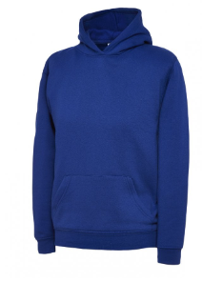

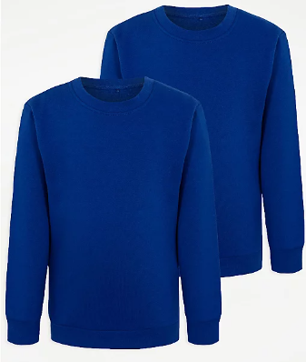

* White polo shirt

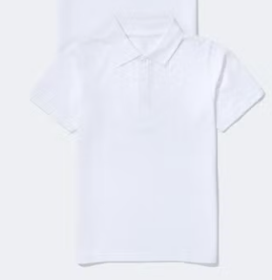

* Black or grey school skirt, pinafore, trousers, joggers or leggings.

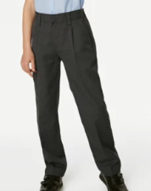

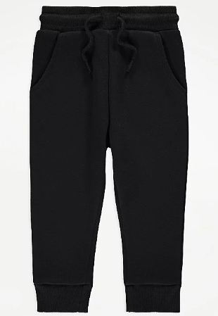

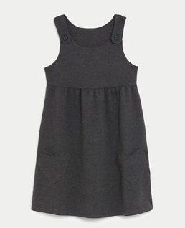

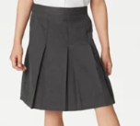

* Plain **dark** sensible shoes or trainers (no heels or sandals)
* Black/white socks and black or grey tights.
* An **outdoor coat**, every day.

**Our pupils will be encouraged to play outside whatever the weather and they will get dirty. Please don’t but expensive coats and shoes.**

**4.2 Our School’s PE Kit**

Fashion sports clothing, crop tops and football tops are NOT permitted.

**Pupils are expected to wear:**

* Black or navy shorts, joggers or leggings

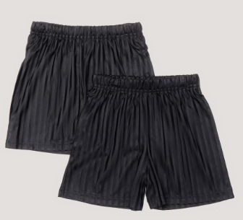

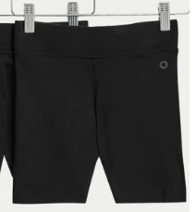

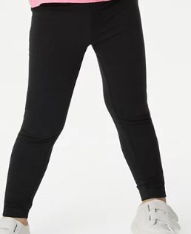



* White t shirt or polo shirt



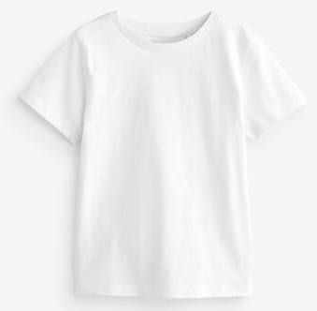

Suitable trainers

* Trainers or other sports shoes suitable for running (no slip on or fashion shoes)

**4.3 Where to purchase it?**

There is no expectation for uniform to have the school logo, if you wish to purchase any branded school uniform it is available vie our supplier, [www.totstoteams.com.](https://www.totstoteams.com./)

Some stores are also now selling a range of uniform items designed to support pupils with sensory needs as well as helping with independent dressing. George at Asda, Sainsburys, Tesco and Marks and Spencer both have a range of uniform items:

[https://direct.asda.com/.../D28M110G1C3,default,sc.html](https://direct.asda.com/george/collections/easy-on-easy-wear-school/D28M110G1C3,default,sc.html?fbclid=IwAR15yHb2URUjNP6hMMSeVNjZtOsCMghIYabRGwlGjDdzw1PPCmyF7ziOrg8)

[https://www.marksandspencer.com/l/kids/easy-dressing](https://www.marksandspencer.com/l/kids/easy-dressing?fbclid=IwAR1vhrlN553hOmVXG50yXfmtxrNwZUHXtjCT2R1beozf0Hw_1x92DYhAhlg)

**4.4 Wearing Jewellery**

* The wearing of earrings is discouraged, where children must wear small stud earrings, these must be removed on PE days.
* Pupils wearing any other jewellery will be asked to remove it and it will be kept safe until the end of the school day. As per health and safety procedures school staff are not permitted to remove a child's earrings therefore if they are unable to remove them a parent/carer will be contacted to come into school to remove them or tape will need to be provided to protect them.

**5. Expectations for our school community**

**5.1 Pupils**

Pupils are expected to wear the correct uniform at all times (other than specified non-school uniform days) while:

* On the school premises
* Travelling to and from school
* At out-of-school events or on trips that are organised by the school, or where they are representing the school (if required)

Parents are also expected to contact the school office, if they want to request an amendment to the uniform policy in relation to their protected characteristics.

**5.2 Parents and carers**

Parents and carers are expected to make sure their child has the correct uniform and PE kit, and that every item is:

* Clean
* Clearly labelled with the child’s name
* In good condition

Parents/carers are also expected to contact the Head Teacher, Mrs. Beattie, if they want to request an amendment to the uniform policy in relation to:

* Their child’s protected characteristics
* The cost of the uniform

Parents/carers are expected to lodge any complaints or objections relating to the school uniform in a timely and reasonable manner.

Disputes about the cost of the school uniform will be:

* Resolved locally
* Dealt with in accordance with our school’s complaints policy

The school will work closely with parents/carers to arrive at a mutually acceptable outcome.

**5.3 Staff**

Staff will closely monitor pupils to make sure they are in correct uniform. They will give any pupils and families breaching the uniform policy the opportunity to comply, but will follow up with the headteacher if the situation doesn’t improve.

Ongoing breaches of our uniform policy will be dealt with by a member of the senior leadership team.

In cases where it is suspected that financial hardship has resulted in a pupil not complying with this uniform policy, staff will take a mindful and considerate approach to resolving the situation.

**5.4 Governors**

The governing board will review this policy and make sure that it:

* Is appropriate for our school’s context
* Is implemented fairly across the school
* Takes into account the views of parents/carers and pupils
* Offers a uniform that is appropriate, practical and safe for all pupils

The board will also make sure that the school’s uniform supplier arrangements give the highest priority to cost and value for money, for example by avoiding single supplier contracts and by re-tendering contracts at least every 5 years.